**Relational Database Model**

RDBMS stands for Relational Database Management System. RDBMS data is structured in database tables, fields and records. Each RDBMS table consists of database table rows. Each database table row consists of one or more database table fields. RDBMS store the data into collection of tables, which might be related by common fields (database table columns). RDBMS also provide relational operators to manipulate the data stored into the database tables. Most RDBMS use SQL as database query language.

The most popular RDBMS are MS SQL Server, DB2, Oracle and MySQL.

The relational model is an example of record-based model. Record based models are so named because the database is structured in fixed format records of several types. Each table contains records of a particular type. Each record type defines a fixed number of fields, or attributes. The columns of the table correspond to the attributes of the record types. The relational data model is the most widely used data model, and a vast majority of current database systems are based on the relational model.

**Structure of RDBMS**

What is table

The RDBMS database uses tables to store data. A table is a collection of related data entries and contains rows and columns to store data.

A table is the simplest example of data storage in RDBMS. Let's see the example of student table.

|  |  |  |  |
| --- | --- | --- | --- |
| **ID** | **Name** | **AGE** | **COURSE** |
| 1 | Ajeet | 24 | B.Tech |
| 2 | aryan | 20 | C.A |
| 3 | Mahesh | 21 | BCA |
| 4 | Ratan | 22 | MCA |
| 5 | Vimal | 26 | BSC |

What is field

Field is a smaller entity of the table which contains specific information about every record in the table. In the above example, the field in the student table consist of id, name, age, course.

What is row or record

A row of a table is also called record. It contains the specific information of each individual entry in the table. It is a horizontal entity in the table. For example: The above table contains 5 records.

Let's see one record/row in the table.

|  |  |  |  |
| --- | --- | --- | --- |
| 1 | Ajeet | 24 | B.Tech |

What is column

A column is a vertical entity in the table which contains all information associated with a specific field in a table. For example: "name" is a column in the above table which contains all information about student's name.

|  |
| --- |
| Ajeet |
| Aryan |
| Mahesh |
| Ratan |
| Vimal |

NULL Values

The NULL value of the table specifies that the field has been left blank during record creation. It is totally different from the value filled with zero or a field that contains space.

**Database Schema**

A database schema is the skeleton structure that represents the logical view of the entire database. It defines how the data is organized and how the relations among them are associated. It formulates all the constraints that are to be applied on the data.

A database schema defines its entities and the relationship among them. It contains a descriptive detail of the database, which can be depicted by means of schema diagrams. It’s the database designers who design the schema to help programmers understand the database and make it useful.

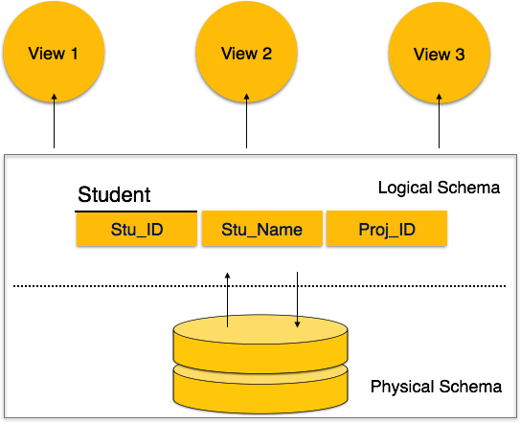

A database schema can be divided broadly into two categories −

* **Physical Database Schema** − This schema pertains to the actual storage of data and its form of storage like files, indices, etc. It defines how the data will be stored in a secondary storage.
* **Logical Database Schema** − This schema defines all the logical constraints that need to be applied on the data stored. It defines tables, views, and integrity constraints.

**Database Instance**

Database schema is the skeleton of database. It is designed when the database doesn't exist at all. Once the database is operational, it is very difficult to make any changes to it. A database schema does not contain any data or information. A database instance is a state of operational database with data at any given time. It contains a snapshot of the database. Database instances tend to change with time. A DBMS ensures that its every instance (state) is in a valid state, by diligently following all the validations, constraints, and conditions that the database designers have imposed.

**Schema Diagram**

Employee

|  |  |  |  |  |  |  |
| --- | --- | --- | --- | --- | --- | --- |
| Street | City | Country | Emplyeeid | Birthdate | Gender | did |

Department

|  |  |  |
| --- | --- | --- |
| Name | Departmentid | eeid |

Locations

|  |  |
| --- | --- |
| locid | name |

Project

|  |  |  |
| --- | --- | --- |
| projectid | name | depid |

Works on

|  |  |  |
| --- | --- | --- |
| eid | pid | hours |

**Keys**

Keys play an important role in the relational database.It is used to uniquely identify any record or row of data from the table. It is also used to establish and identify relationships between tables.

For example:  In Student table, ID is used as a key because it is unique for each student. In PERSON table, passport_number, license_number, SSN are keys since they are unique for each person.

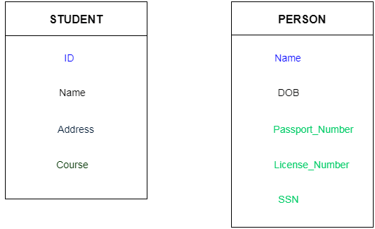

**Types of Keys**

1. **Super key**
2. **Candidate key**
3. **Primary key**
4. **Alternate key**
5. **Foreugn key**
6. **Composite key**
7. **Super key**

Super key is a set of an attribute which can uniquely identify a tuple. Super key is a superset of a candidate key.

Employee

|  |
| --- |
| Employee_id |
| Employ_name |
| Employee_address |
| passport_no. |
| Liscence_no. |
| Atmcard no. |

**For example:** In the above EMPLOYEE table, for (EMPLOEE_ID, EMPLOYEE_NAME) the name of two employees can be the same, but their EMPLYEE_ID can't be the same. Hence, this combination can also be a key.

The super key would be EMPLOYEE-ID, (EMPLOYEE_ID, EMPLOYEE-NAME), etc.

1. **Candidate key**

Each table has only a single primary key. Each relation may have one or more candidate key. One of these candidate key is called Primary Key. Each candidate key qualifies for Primary Key. Therefore candidates for Primary Key is called Candidate Key.

Candidate key can be a single column or combination of more than one column. A minimal super key is called a candidate key.

**For example:** In the EMPLOYEE table, id is best suited for the primary key. Rest of the attributes like SSN, Passport_Number, and License_Number, etc. are considered as a candidate key.

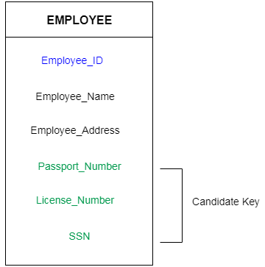

1. **Primary Key**

It is the first key which is used to identify one and only one instance of an entity uniquely. An entity can contain multiple keys as we saw in PERSON table. The key which is most suitable from those lists become a primary key.

In the EMPLOYEE table, ID can be primary key since it is unique for each employee. In the EMPLOYEE table, we can even select License_Number and Passport_Number as primary key since they are also unique.

For each entity, selection of the primary key is based on requirement and developers.

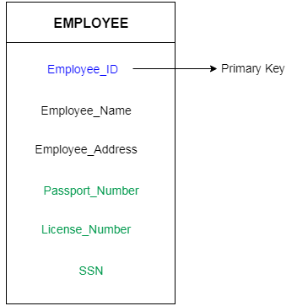

1. **Foreign key**

Foreign keys are the column of the table which is used to point to the primary key of another table.

In a company, every employee works in a specific department, and employee and department are two different entities. So we can't store the information of the department in the employee table. That's why we link these two tables through the primary key of one table.

We add the primary key of the DEPARTMENT table, Department_Id as a new attribute in the EMPLOYEE table.

Now in the EMPLOYEE table, Department_Id is the foreign key, and both the tables are related.

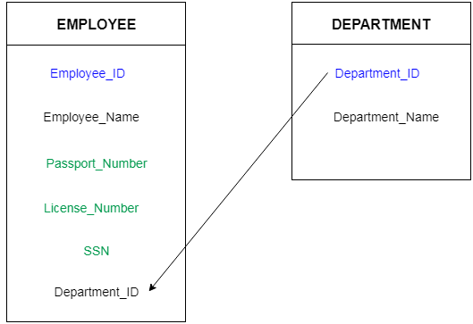

1. **Composite key**

A composite key is a combination of two or more columns in a table that can be used to uniquely identify each row in the table when the columns are combined uniqueness is guaranteed, but when it taken individually it does not guarantee uniqueness.

Sometimes more than one attributes are needed to uniquely identify an entity. A primary key that is made by the combination of more than one attribute is known as a composite key.

In other words we can say that:

Composite key is a key which is the combination of more than one field or column of a given table. It may be a candidate key or primary key.

